# Fixing Email Signups Across Search Tools

For this project, I initially started by investigating a feature request that we had received from one of our end user departments. The team I work on is responsible for creating search tools and functionality that enable people to locate government content across GOV.UK, and we have two categories of users - citizen end users, and department end users. Citizens will use the search tools to locate content, but departments will make requests to us directly to request specific tools be built in order for their content to be made more accessible. Because each department has a more specialised knowledge of their content, we communicate with them to create the most appropriate tools.

This particular feature request came from the Animal and Plant Health Agency (APHA). They wanted their existing search tool to have a link that allowed their users to sign up to email alerts. Their tool is used by food exporters to identify which certificates would be required to export products abroad. The screenshot below shows their search tool in its old format. You can see that along the side of the tool, a user can add keywords to refine the search, as well as limiting the search to various countries, commodity types and certificate statuses.

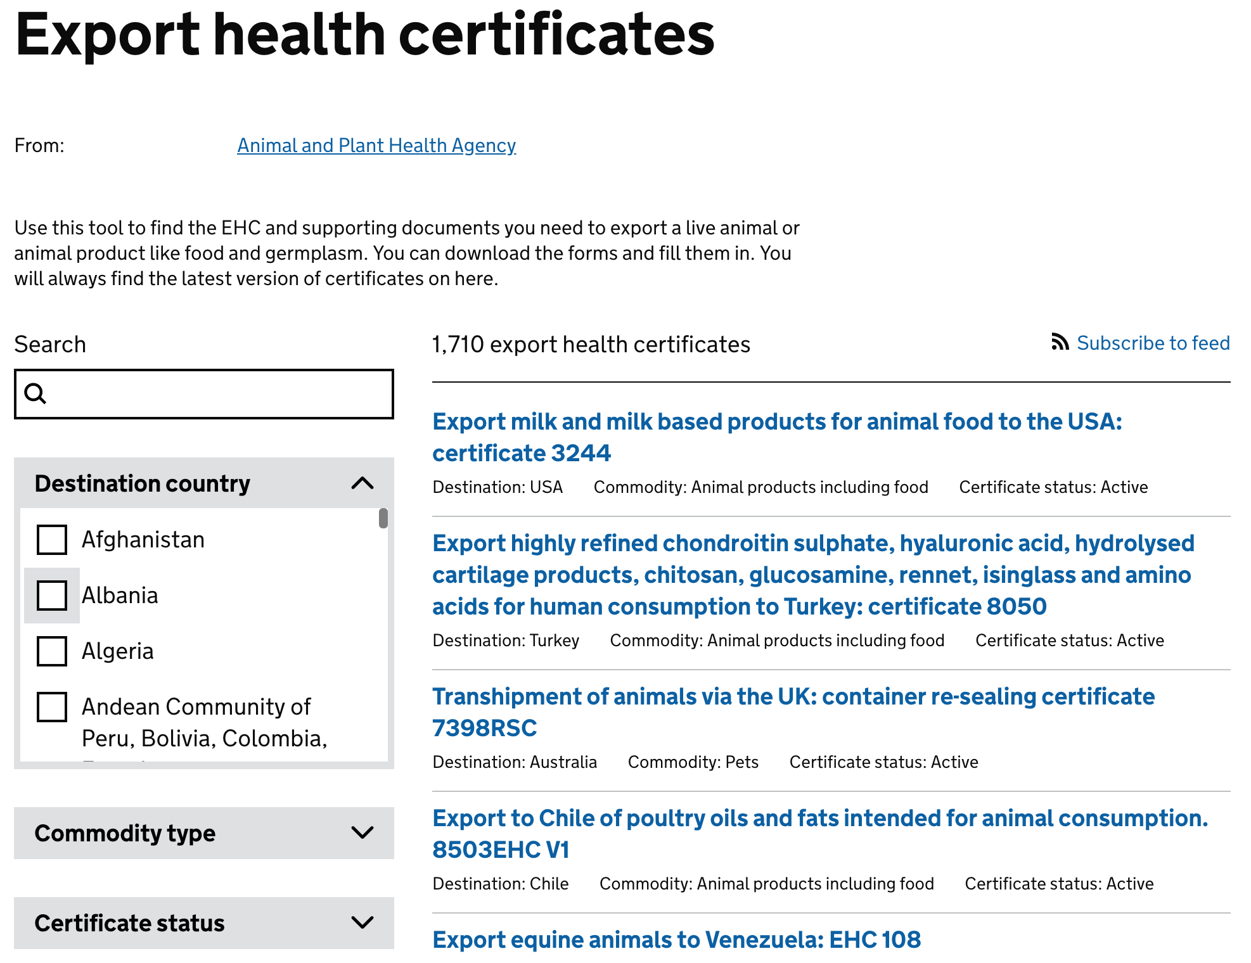

Introducing an email alert would mean that a user could select a specific country, for example Afghanistan, and a commodity type, for example Fish, and if any new certificates were published, or existing certificates were updated, then they would receive an email.

To introduce this change, I would be re-using existing functionality that existed in other search tools, but applying it to the specific tool here. It would involve setting up a link on the search page that enabled a user to create an email subscription, which would then go into a subscription database that gets trawled on a regular basis. I would also need to communicate with the department to make sure that they were happy with the results, and that it met their requirements.

The Trello card that had been written for this ticket is shown below. I first started by looking at the link provided to CMA Cases, which is a similar tool but for different content. This had its own email signup functionality, so I figured that matching this as closely as possible would be appropriate.

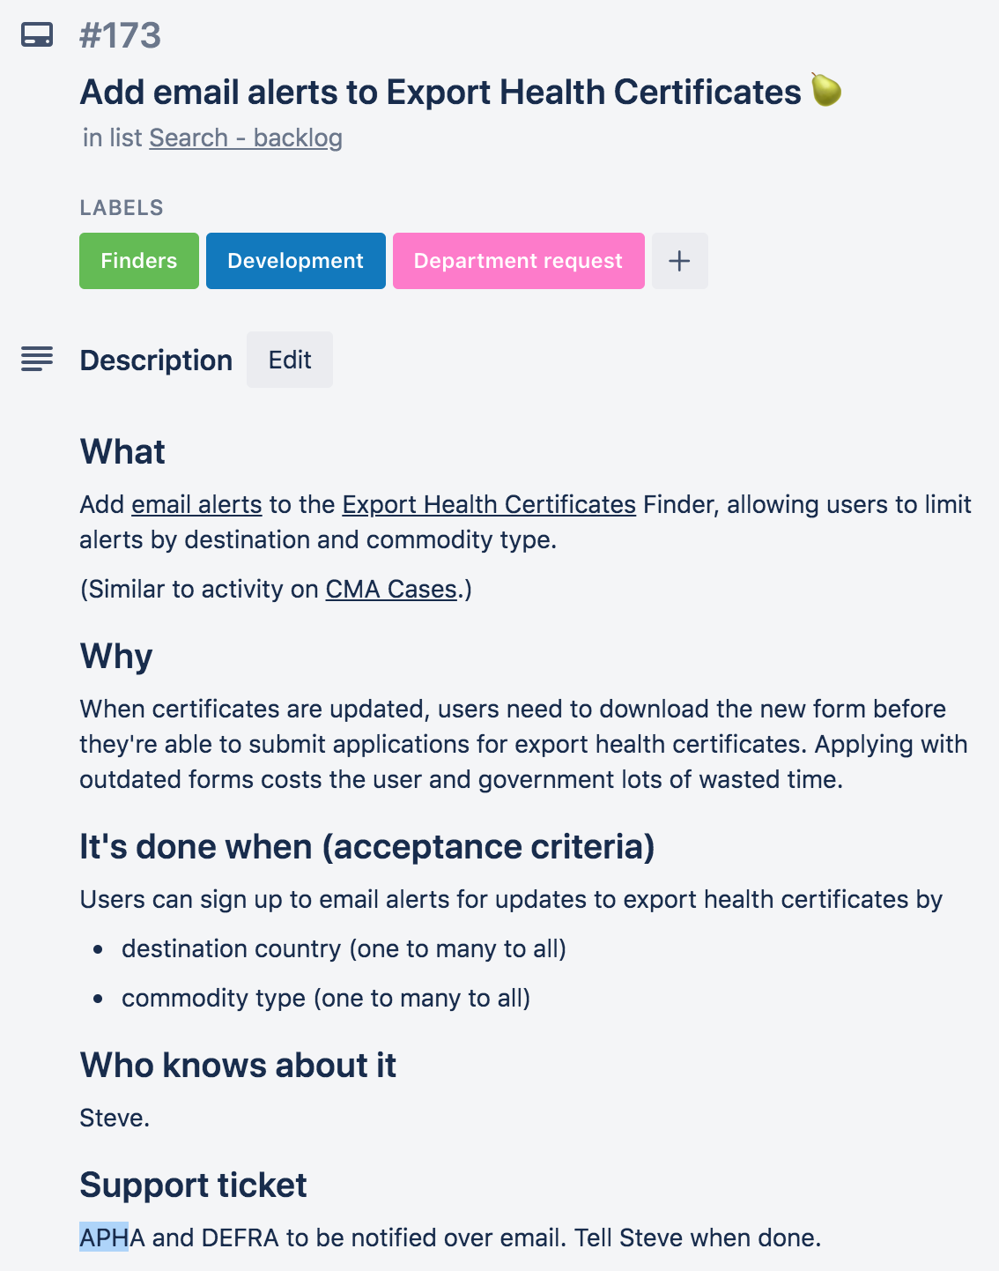

However, when I visited the CMA Cases site, I hit an issue. Although the email signup button was available, as shown below:

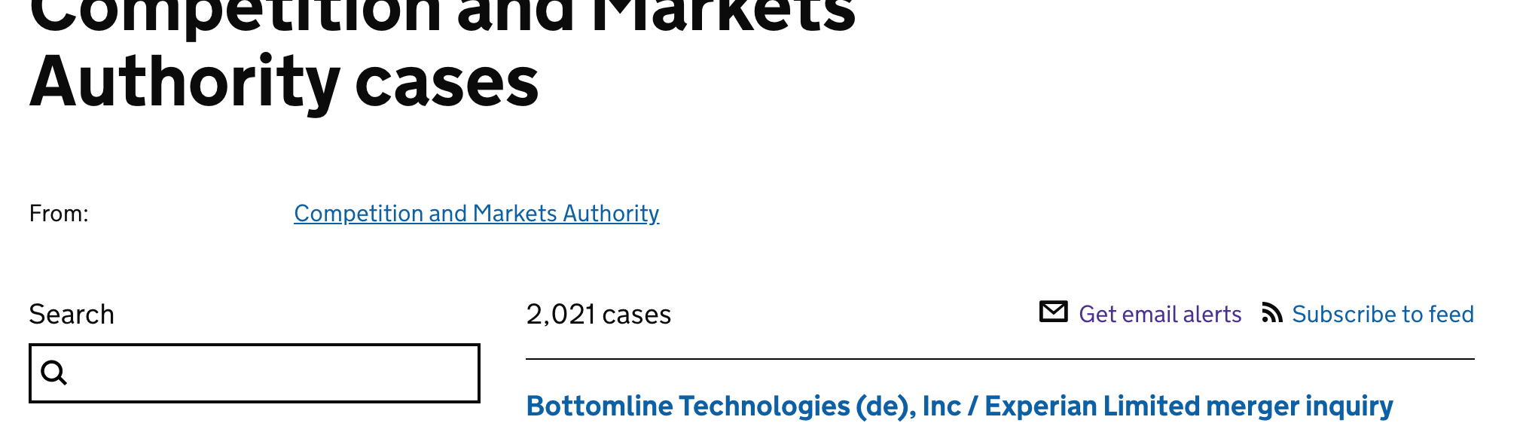

When clicking on the link, it only gave options to filter the alerts by one of the sidebar facets. This would not work for the feature requested by APHA, as they wanted their emails to be filtered by multiple facets - namely Country and Commodity. If I were to copy this format, it wouldn’t meet the requirements set by APHA. I brought this information back to my product manager and tech lead, so that we could work out the best next steps.

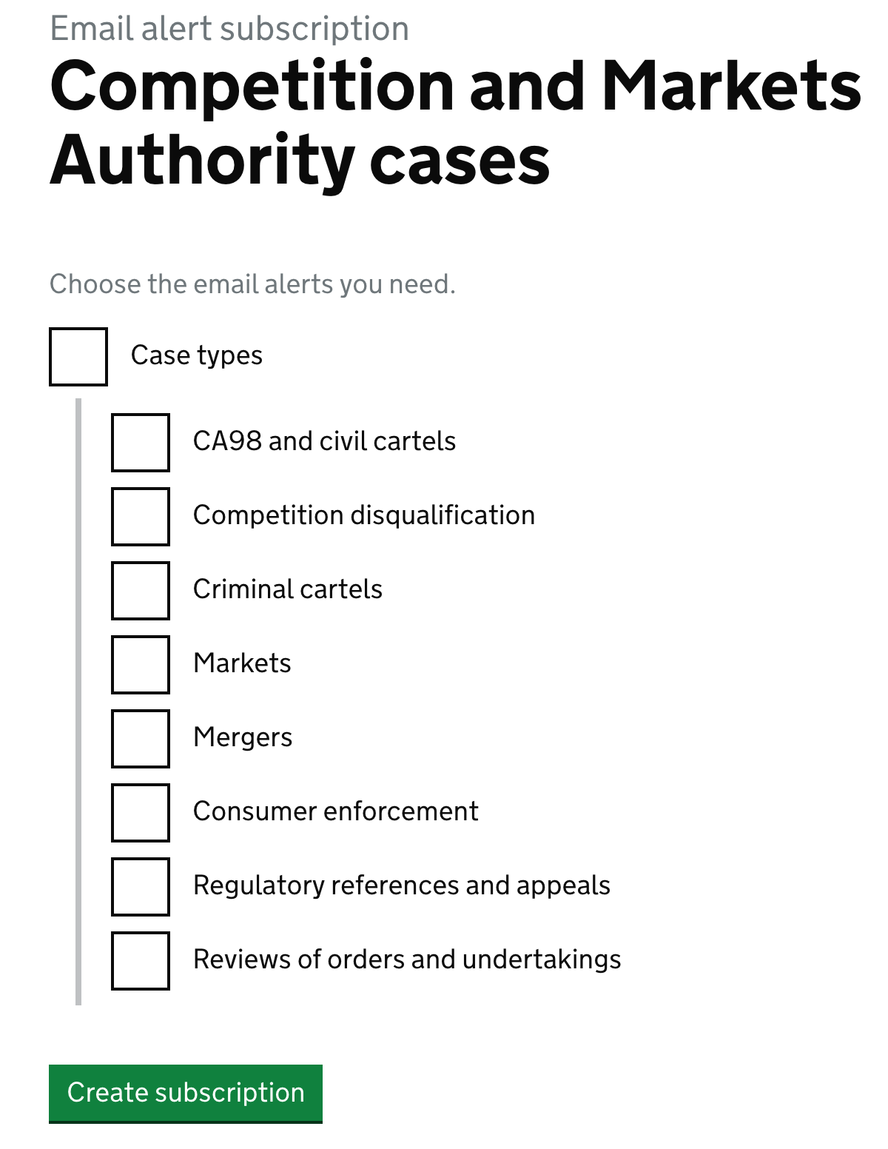

The tech lead let me know that there may be other email signup workflows that worked differently. I went to another search tool, the “News and Communications” search, to see how it handled the email subscriptions.

Here, it worked differently; when I clicked on the email alerts button, it immediately asked if I wanted to create a subscription. There weren’t any checkboxes, and instead it used any of the pre-existing filters that I had applied in the search tool. Interestingly, this included multiple filters at a time. The screenshot below shows the final page of the email signup, where the filters were listed.

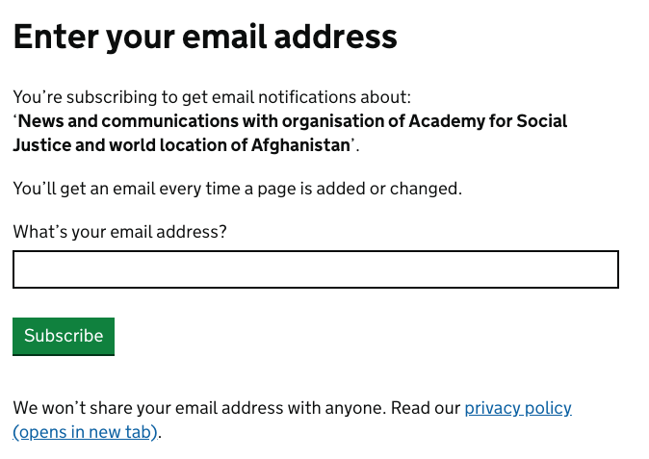

The issue here was that this News and Communications search tool was not as specialised as the Certificates and CMA tools, and it worked off a different backend, which meant transferring code across wouldn’t be as easy. I then tried to find a search tool that used the same backend as the Certificates tool, while still using the more appropriate email signup.

Unfortunately, this is where a bug appeared. There was a tool that used this more suitable format, but it wasn’t applying any filters when it reached the final page. This meant that someone signing up to emails would receive a notification whenever a new search result would appear in that tool, with no filtering whatsoever. For the case of the Certificates search tool, this could introduce a lot of noise to an email subscription, where a certificate for any country and any product would trigger an email.

I brought this information back to the team, and my product manager asked me to create a series of tickets that explored the options that were available - this would allow us to pick up this work at a later date, as it was starting to turn into several things. I created three new cards, and put them in the team backlog. The card below shows my comment on the main ticket that set out the options.

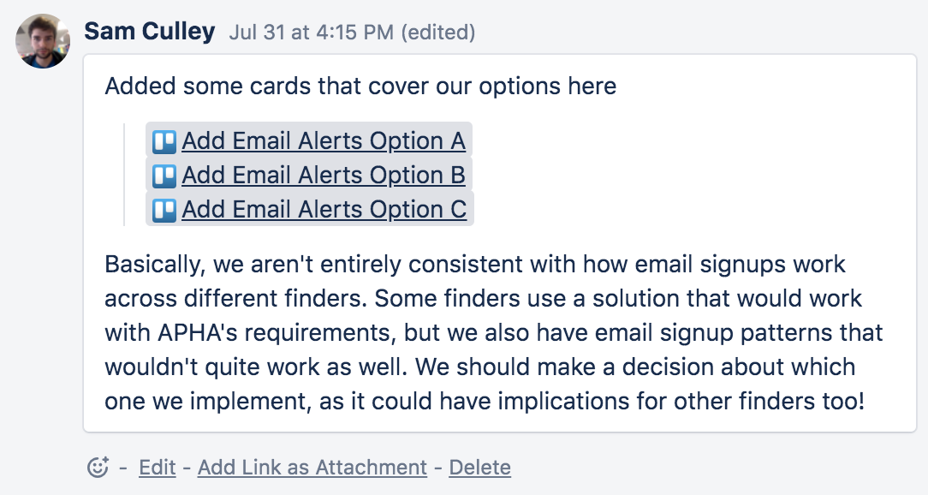

The new cards each contained one of the options - we could either fix both email signup formats, or merge one into the other (in either direction). The team didn’t have the capacity to reach a decision on this so it was parked here until later.

As well as the options for resolving the feature request, I also created a new ticket that related to the bug for the email signup not having any filters.

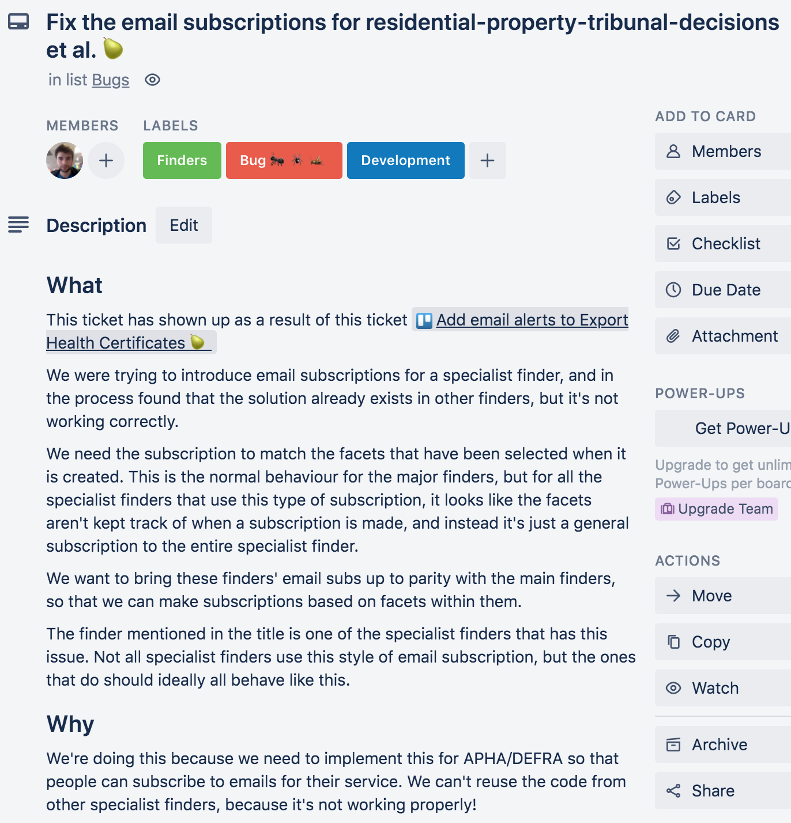

I spoke with a senior developer on my team to find out how exactly this all fit together in the backend. It turned out there was a fairly complicated mess to untangle, as different search tools were using the different signup options inconsistently. The screenshot below shows some values in the schema for the tools, and how some fields are different for the News and Communications tool (line 16), as compared to the Brexit Guidance tool (line 12).

**News and Communications**

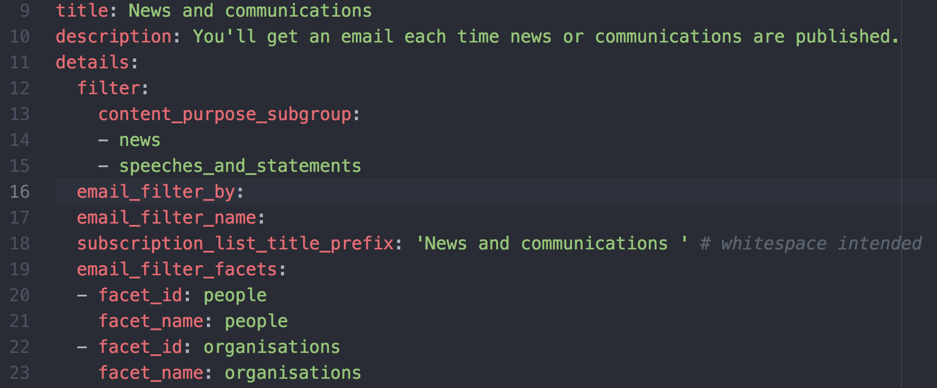

**Brexit Guidance**

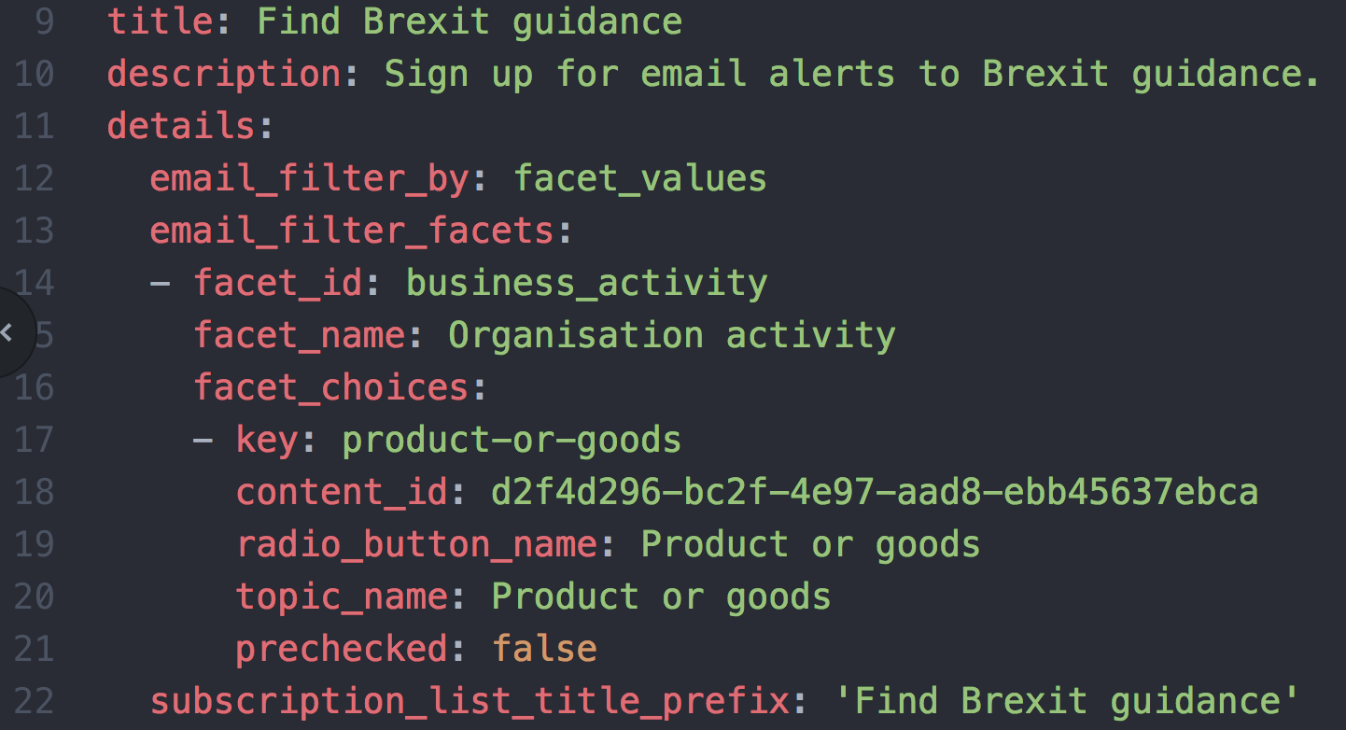

Additionally, there were other people on the team who had also had to start working on fixing a different issue that had shown up for email alerts, which meant until that was resolved, any changes that I might make now would need to be merged into theirs, potentially causing some conflicts.

As a result, I spoke with my tech lead, and we both agreed that this would need to be parked for the time being. He suggested that I write a tech debt ticket, that would go into our large tech debt tracking board. Here it could be picked up at a more appropriate time.

The screenshot below shows the tech debt card that I wrote. I explained the current issue, linked to the pre-existing team tickets, and set out a range of possible ways to resolve this.

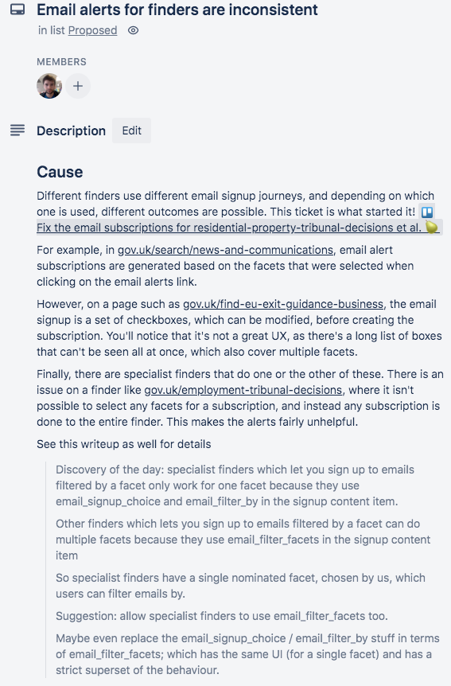

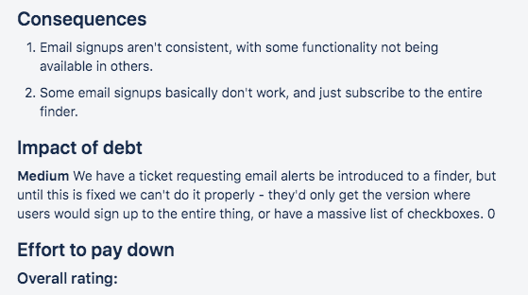

At this point, I wasn’t able to progress the ticket any further, so I tidied up the original tickets on the team board, linked across to the tech debt ticket where appropriate, and let the team know at the next daily standup how things had resolved.

## Summary

Although this work didn’t involve me writing any code, it did involve me doing a lot of investigative work and speaking to a range of team members. This ended up being quite valuable, as I learned about the business processes that would deal with this sort of occurence. In particular, I learned about the tech debt tracker, which was a suitable place for issues that were known to exist, but wouldn’t be resolvable in the short term.

Writing a ticket for the tech debt board was a good experience, as it required me to think about how to describe the issue to someone who’s never seen any of this before, and who might end up working on this months or even years later. I had to provide links to the tools for examples, and assess what the impact of this was. This meant it could later be measured up against other tech debt to see what priority it should be given.

I did have to analyse a bit of the backend code as well, just to get an understanding of how complicated it would end up being. The main challenge here was locating the specific area of the code that dealt with the email signups for the tools, as this was located separately from the tool configurations.

The end result was a ticket in the tech debt tracker, and having to let the user know that this wouldn’t be possible in the short term, but that we’d be able to resolve it once it had been prioritised appropriately given the amount of work needed.